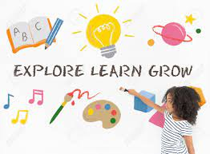
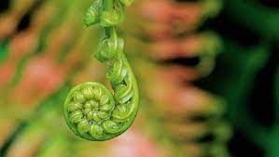

CUST SCHOOL
2023 CURRICULUM OVERVIEW
SCHOOL THEME: GROW / TUPU
ASPIRATIONAL TEACHING AND LEARNING | A CULTURE OF COLLABORATIVE RELATIONSHIPS | SELF-MOTIVATED, POSITIVE AND RESPONSIVE CITIZENS | HIGHLY RESPONSIVE TO OPPORTUNITIES AND CHALLENGES
Develop a localised curriculum, which offers learners / ākonga high quality learning experiences in all areas.  GROW AS A TEACHER | Enhance collaborative practices, within and outside of our school, based on relational trust, allowing capability to grow.  GROW AS A TEACHING COMMUNITY | Effectively monitor the “wellbeing” of our students, staff and whanau and promote a range of practices that develop a strong sense of belonging and wellbeing.  GROW AS A PERSON | Ensure we are responsive to opportunities and outcomes, so we can offer teaching, learning and leadership which equips our learners / ākonga, school and community with an understanding of:  *Identity / belonging / culture  GROW AS A COMMUNITY/CULTURE
Review, embed and implement HITS (High Impact Teaching Strategies) to Cust School Localised Curriculum.  HOW:  Develop improved teaching practices that lead to improved learning outcomes & achievement for all tamariki - CONSCIOUS ACTS OF TEACHING  Use and evaluate our new Maths, Reading and Writing Programmes of Work – coherence – refreshed curriculum  Examine ways to improve outcomes and accelerate progress/achievement with our below and well below tamariki – The Code / Structured Literacy / SENCO | Develop inquiry led professional growth cycles and quality professional learning circles to deliver improved outcomes.  HOW:  Develop school/syndicate wide coaching and mentoring initiatives - engaging in learning conversations, peer observations and challenging conversations.  Model a collaborative strong teaching and support team that value and model effective communication to lead change  Create a supportive team with a consistent approach to high quality teaching and learning | Identify and evaluate models of Student Well Being  HOW:  Create well-being topics as suggested in our annual well-being plan  Term 1 – MANA – GROW YOUR MANA  Represent our school values (TIPS) so they are clear, visible within our school and class environment, and are part of our daily learning programme.  Model and discuss positive behaviors within our school community through engagement in our PB4L programme. | Demonstrate and develop meaningfully ways of incorporating te reo Māori and tikanga Māori into the everyday life of the place of learning  HOW:  Use our newly developed Māori language acquisition plan to tamariki, kaiako and whānau.  Illustrate that Te reo Māori is incorporated in daily conversations with increased confidence by kaiako, tamariki and whānau  Model that value is placed on normalising te reo Māori

